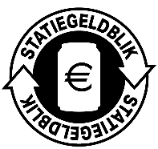
Annex II. Deposit logo metal beverage cans

The following rules apply to the use of the logo:
- the logo must be placed on the consumer unit and therefore does not have to be placed on outer packaging/multi-packs and/or trays/boxes;
- The ratio of the logo, in combination with the prescribed minimum letter height of 1.2 mm, results in a minimum size of the logo of 1.2 cm2. The user is free to use the logo in a larger format;
- No changes may be made to the logo;
- The length/width ratio of the logo may not be changed;
- The logo may be printed in all desired colors, both positive and negative, as long as it remains recognizable, legible and in the correct proportion;
- The logo is made available digitally in the formats .pdf, .png and .eps;
- The mentioning of the deposit amount on the metal cans is not mandatory;
- The ownership and copyrights of the logo rest with Afvalfonds Verpakkingen.

